SCHOOL DISTRICT 63 (SAANICH)
FINANCE, FACILITIES & TECHNOLOGY COMMITTEE
Agenda
Committee Members: Trustee Martin, Chair, Trustee McMurphy, Trustee VanWell, Trustee Dunford, Trustee Holman, Trustee Silzer, Trustee Stelk
Staff Support: Jason Reid, Secretary-Treasurer Dave Eberwein, Superintendent of Schools Megan Cimaglia, Director of Finance Rob Lumb, Director of Facilities Cody Henschel, Director of Information Technology
Partner Representatives: Michael MacEwan, STA Nola Welsh, CUPE David Mark, SAA Ashley Sonosky, COPACS
Tuesday, October 12, 2021 10:30 am
A. PRESENTATIONS AND QUESTIONS
Energy Plan – Rob Lumb & Erica Letchford, Rede Energy Solutions
- This was a report on SD 63 Energy Management. The timing of this report was moved from May to October to better align with the finalization of Green House Gas (GHG) data. Because of this, the data present was that from the May report.
- Presentation contained updates on projects and work to create an Energy Sustainability Plan which will identify the steps necessary to meet GHG reduction targets.
- Current Projects: CDC Replacement – 99% complete – building design using LEED GOLD standards
Bayside Boiler Replacement – new system will result in a decrease of 50% GHG emissions – boiler water additive being used that is reported to be capable of increasing heat transfer up to 15% - if see positive results will be looking at use throughout the district – this chemical is akin to the opposite of anti-freeze in a vehicle – it is used in a closed water system so chemical does not reach the air breathed by students and staff
Replacement dust collector at facilities office delayed until March 2022 due to long lead times for equipment
Upgrade to facilities power underway – expected completion December 2021. Will increase power available to the School Board Office and allow for electric busing infrastructure
Have submitted for 3 electric buses in this year’s capital budget and will know if approved by March 2022
Have submitted applications to the Continuous Optimization Program – a joint offer from BC Hydro and FortisBC which provides customer assistance to save energy and improve operations in large commercial buildings without having to undertake a major capital investment. Primary focus of program is to help improve the efficiency of energy-insensitive systems such as heating, ventilation and air-conditioning (HVAC) with simple, low-cost solutions. They will fund 100% of the cost for a re-commissioning expert.
- Challenges: $$$ - Only have $400k in funding annually to rely on – District requires $20.5m in building retrofits to meet 2030 reduction mandate. With only 8 years until that time, have a deficient of $17.3 in funding
Electric Buses – bus replacement is dictated by the Ministry based on an age/mileage formula – by 2030, will have 16 buses that should qualify for replacement based on this formula – total cost per electric bus is $427k – current funding available for buses is $302k = $125k deficit per bus – therefore will need at least $2m in local contributions
- Presentation from Rede Energy Solutions (pronounced READY) of The Energy Sustainability Plan – used results from a consultant that visited each of the District’s sites to review the condition of each site’s mechanical infrastructure and provide recommendations for renewal and upgrades
- provided baseline targets and identified GHG category priorities as buildings, fleet and paper
- you can find the entire presentation attached to the Meeting’s agenda on the district’s website here: SCHOOL DISTRICT NO (sd63.bc.ca)
- Discussion on board’s role in advocating for additional funding – motion approved to write a letter to Ministry of Education and Minister of Environment and Climate Change Strategy – copy to STA – advocating additional funding and support for school districts to meet the 2030 Clean BC – also suggestion to copy to Federal Government

B. ITEMS FOR DISCUSSION No Items.
C. ITEMS FOR RECOMMENDATION
1. Final Enrolment & Funding – briefing note to follow
Attached here:
- Final enrollment confirmed on Friday (October 8th)
- Growth in enrollment in neighbourhood schools and in students designated with unique needs
- Because of this, additional staffing budget increases were proposed as 5 new enrolling divisions were added prior to school start-up (4 at elementary and 1 at middle)
- Note $2.8m appropriated from accumulated surplus to balance preliminary budget
- Recommended that surplus from operations at the end of last year be allocated to budget contingency reserve

2. White Road Funding Application Staff Recommendation: That the Board approve submission of a funding application to the BC Childcare New Spaces Fund to develop a childcare and early learning program in partnership with Beacon Community Services, conditional on the project cost estimate being $3,000,000 or less.
- In October 2020, a submission for funding to the BC Childcare New Spaces Fund was submitted to develop a nature based early learning centre on the White Road property for children aged 3-5 to facilitate the creation of a robust program that would integrate with district programs to create a more seamless transition from early learning into K-12
- the submission was not successful – Ministry staff (Ministry of Children and Family Development) provided that it was a strong application but when it was submitted, there was no operator for the facility
- because of this feedback, the Board approved partnering with Beacon Community Services on the project given the district already has several programs partnerships with them
- Applications are now open to be submitted until November 16, 2021 – projects that on increase infant/toddler child spaces will be given priority – the vision of the new submission is a nature based early learning and childcare program that creates 82 childcare spaces and provided additional support programs for families:
- infant/toddler care – 12 spaces
- full time group care ages 3-5 – 24 spaces
- part time group care ages 3-5 – 24 spaces
- after school child care – 24 spaces
- also contains additional support programs will include programming for early years and young parents, counselling services and other family support programs
- this nature based program will be rooted in W̱SÁNEĆ ways of knowing and being and be exposed to the SENĆOŦEN language – woven through the program would be the First Peoples’ Principles of Learning by engaging with local W̱SÁNEĆ elders and educators to ignite an understanding on Indigenous perspective
- motion contingent on project cost estimate less than $3m – looks like it will but will be tight
D. ITEMS FOR INFORMATION
1. Prospect Lake Parking Lot
- working with district of Saanich to improve road works around the school – Saanich has offered to expand on site parking as opposed to street parking – initial estimate $200k – now engineering design finalized - cost is now $425k – have not committed to anything yet as feel this amount is too high – will have to wait until tenders come in which will be in the spring – think that cost will be somewhere between the initial $200k and the $425k – this information provided as a heads up – District doesn’t have to commit to project until after tenders come in
2. CDC Traffic Query
- motion at last board meeting to discuss with school staff regarding speed and volume of traffic – administrator indicated he was not aware of any concerns – this goes against anecdotal comments made by those living in the community – will move forward with staff discussion with Saanich police

SCHOOL DISTRICT 63 (SAANICH)
POLICY DEVELOPMENT COMMITTEE
Agenda
Committee Members: Trustee Stelck, Chair Trustee Holman Trustee Martin and Trustee McMurphy, Trustee Silver, Trustee Dunford, Trustee VanWell
Staff Support: Dave Eberwein, Superintendent of Schools Jason Reid, Secretary Treasurer Leigh Glancie, Sr. Exec Admin
Assistant Partner Representatives: Michael MacEwan, STA Nola Welsh, CUPE Pete Westhaver, SAA Ashley Sonosky, COPACS
Tuesday, October 12, 2021 1:00 pm
A. PRESENTATIONS AND QUESTIONS
No Items.
B. ITEMS FOR DISCUSSION
1. Policy 18 (Recruitment & Selection of Personnel) – clarity on hiring authority
- discussion of senior district personnel (Board office, principals and vice-principals)
- used to have three policies – now being brought together under one - consistent involvement of all partners in these and in new one
- discussion for cases when there is no consensus
2. Correspondence
- brought up by Trustee Holman – she had submitted correspondence with regard board committee and board operation procedures – has not been brought up to date – Has heard from members of community it is unclear how to correspond with board trustees or committees – noted that there is very little correspondence that makes it public meetings – so does this lack of clarity contribute to this
- will be a recommendation made from the committee to the Board to direct staff to formulate a policy around correspondence
3. Review of Board Motions
- Briefing Note attached to Agenda here : SCHOOL DISTRICT NO (sd63.bc.ca)
- new policy to review these annually – only one motion that would have an enduring impact – this would require to be considered to be added to district policy
- discussion on recording and archiving Board of Education meetings and committee meetings and whether this motion should be made policy – recommendation to move to board for discussion and direction
C. ITEMS FOR RECOMMENDATION
1. Policy 19 (Accumulated Operating Surplus) Staff Recommendation:
i) That the Board approve consideration of the proposed changes to Policy 19 (Accumulated Operating Surplus)
ii) That dependent on the Board’s confirmation of consideration, the Policy Committee provide a Notice of Motion.
- came about because of a change in legislation
- policy development discussion led by Jason – old practice inconsistent with new policy (policy #6) – need to change practice – before committee chair provides notice of motion, the board should approve this consideration – so new practice should be that the Board approve consideration of proposed changes and then the committee will provide a notice of motion – discussion on this amongst trustees
D. ITEMS FOR INFORMATION
No Items.
E. FUTURE AGENDA ITEMS
That the following remain as policies pending a review by the Board about what portions of these programs the Board wishes to retain as policy:
♣ Policy 7 (Board Committees)
♣ Policy 9 (Board Operations)
♣ Policy 1 (Foundational Statements)
♣ Core French
♣ SENCOTEN Language (in conjunction with Strategic Plan)
♣ Evaluation Process for Secretary Treasurer
♣ Diversity & Inclusion

SCHOOL DISTRICT NO. 63 (SAANICH)
EDUCATION DIRECTIONS COMMITTEE
AGENDA
Committee Members: Trustee VanWell, Chair Trustee Silzer Trustee Stelck - also Alicia Holman, Elsie McMurphy, Timothy Dunford
Staff Support: Carly Hunter, Director of Instruction Dave Eberwein, Superintendent
Partner Representatives: Kelly De Klerk (SAA) – secondary Ashley Sonosky (COPACS), Michael MacEwan (STA) Nola Welsh (CUPE) – Aaron Buckingham
Other Attendees: Melissa Austin, District Principal, Indigenous Education Lynn Montgomery, Teacher (Stelly’s)
Tuesday, October 12, 2021 3:00pm ILC Saanichton
A. PRESENTATIONS AND QUESTIONS
1. P.E. – P.H.E - How Physical and Health Education has evolved over time – Lynn Montgomery
- noted has changed drastically in last few years
- moved from physical education to physical and health education
-focus on hour care areas – physical literacy, health and active living (healthy relationships), social and community health (substance use and abuse), mental well-being (strategies for maintaining positive mental health ie. breathing, mindfulness, yoga, self-reflection)
- focus on supporting students overall health and well being in a broader sense including developing a sense of connection between physical, mental and intellectual and social health
- much broader focus now – expanded to include health and wellness – self-assessment now an integral component – differentiates between physical education and physical literacy
- Assessment more now on proficiency scale than on attitude and effort
- have reached out for assistance with mental health and wellness and community health curriculum – inside district (ie. counsellors) and outside (ie. Island Sexual Health)
2. Indigenous Program Update – Melissa Austin and Carly Hunter
- focus has changed a bit for 2021-22 school year
- Main focuses – must always be based on community feedback (4 local nations)
- extend SENĆOŦEN programs – have language and culture teachers at Brentwood and KELSET – Bayside offers SENĆOŦEN as a second language – also have an outside of timetable course at Stelly’s and some Parkland students will be joining
- ensure all students receive the literacy intervention they need – data tells us in particular status students living on reserve need more support with regard students – additional supports at Brentwood and KELSET in response to this and close learning and literacy gaps – based on populations of those two schools – continue to track this and engage the teachers involved as to how best to support these students
- W̱SÁNEĆ communities reflected visually in schools – Welcome Pole at Claremont – was a student-led initiative – looking at other opportunities for local artists to assist with this
- cultural competency training for all staff – want staff working with Indigenous students to have training around history, cultural, discrimination etc. – so that these students have more positive learning journey than those before them
- support school staff to feel more comfortable infusing Indigenous content – “ownership” as Canadians infusing Indigenous content is a shared responsibility
- guiding questions to exploring equity –continuous discussions among school staff and administration
-How are we making sure all students have access to all pathways?
- How do we create space versus requiring compliance?
- What are our dark corners and how do we reveal them?
- How are we addressing situations where Indigenous students encounter the racism of low expectations?
- How are we addressing implicit bias in our system?
- Cultural Competency Training – completed:
- 7 schools, Transportation and Learning Services, SBO, CUPE Pro-D sessions (x2 so far)
- remaining schools are booked over the course of the school year
- lots of engagement in this process
- now exploring next steps in terms of inservice and Pro-D that follows this training and continues to build capacity and understanding
- next steps
- equitable access to learning for all Indigenous students – removing barriers – creating spaces
- how do we ensure and shift the system so that students experience less racism in their K-12 journey – how do we name this so can move forward
- naming the racism of low expectations
- systemic racism – what is our concreate plan and commitment – what does this look like and what is our plan to address this
- recruitment and retention of Indigenous teachers and support staff – we know how powerful having these role models is
- barriers to access and helping shift the narrative around why we are removing barriers and providing supports – why is there wrap around supports for Indigenous students – why is there a gap in outcomes for these students and how to we lessen them
- strengthen into school system – into school system – how do we navigate the school bus system – strong start – transition to middle and high school and to post secondary and work
- many initiative’s are funded through external grants so need to explore ways to make these sustainable

- Collective Responsibility
- shifting our organizational culture in Saanich to one of Collective Responsibility
- Becoming a system where every person, regardless of role or department takes responsibility for Indigenous student success
- Indigenous Education transcends the boundaries of departments, job descriptions, or formal roles and responsibilities
- Shifting our thinking away from “Indigenous Education for Indigenous students” to “what’s good for Indigenous students is good for all students”
- Sheralyn shared with us comments gathered from both staff and parents in our district to illustrate bias and racism
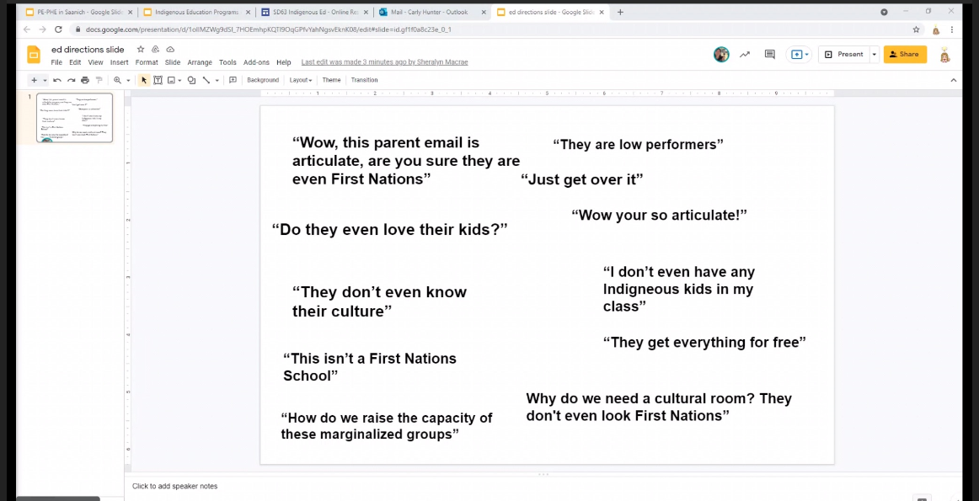
B. ITEMS FOR DISCUSSION (None)
C. ITEMS FOR RECOMMENDATION (None)
D. ITEMS FOR INFORMATION (None)
E. FUTURE AGENDA ITEMS (None)

