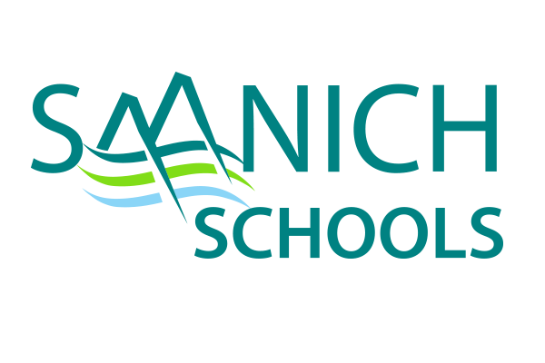
ANNUAL PARENT INVOLVEMENT EVENING
Thursday, February 22, 2024
Stelly’s Secondary School
1627 Stelly’s Cross Road, Saanichton
7:00-8:30pm

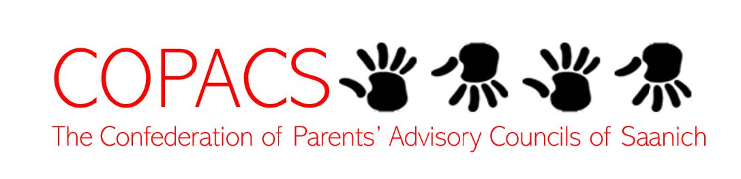

This annual gathering brings together parents and guardians, school and district administration, teachers, and trustees to share information on a variety of timely educational topics.

This year’s theme:
STUDENT SUCCESS: WHAT’S HAPPENING IN SCHOOL TO SUPPORT THE STRATEGIC PLAN AND ITS FOUR THEMES?

The evening will be set up like a fair where you can choose from a variety of school conversations on LITERACY, INDIGENOUS LEARNER SUCCESS, MENTAL HEALTH & WELLNESS or GLOBAL CITIZENSHIP. Schools from across the district will be there to share their learning journeys. The event will start and end in the theatre.

Registration is not required.
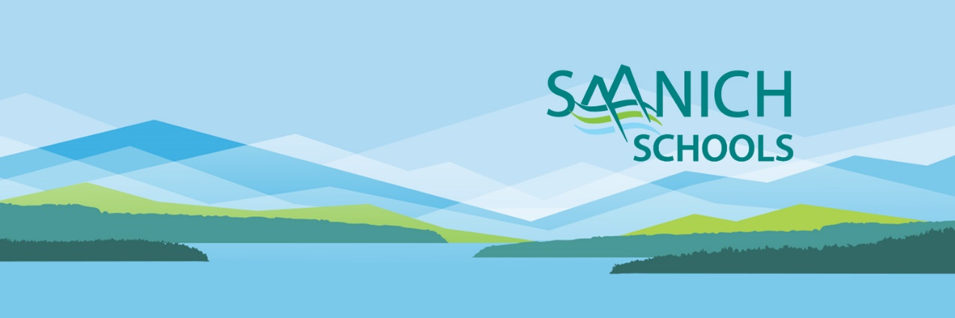
We hope to see you there!

